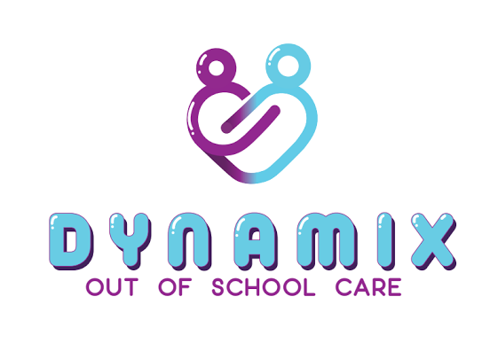

Terms and Conditions
Dynamix Terms and conditions become binding when you complete the enrolment form. We may refuse to accept any application for enrolment from any person.

Fees
Unless advised by management you will need to pay all fee’s two weeks in advance and remain in advance, at time of enrolment. If fee’s are not paid by the due date or kept in advance you acknowledge that care will be suspended immediately.

Fees are subject to change.

Before School Care Fee’s
Full Time (5days) $13.00 per child from 6:45am-9am.
Casual (1-4days) $15.00 per child from 6.45am-9am.
Fees are to be paid 2 weeks in advance. Non-attendance for pre-booked days will be charged at full rate and are non-refundable. We leave for school drop off’s at 8am.

After School Care Fee’s
Full time (5days) $19.50 per child from 2.30pm-6:30pm.
Casual (1-4days) $20.50 per child from 2.30pm-6.30pm.
Fees are to be paid 2 weeks in advance.
Non-attendance for pre-booked days will be charged at full rate and are non-refundable.

No Notice of Absence Fee’s
No notification of an absence for After School Care will incur an additional charge of $20 on top of the daily charge.

If a refund is given you can provide your bank details for a direct credit. We do not give cash refunds.

No Refunds
There are no refunds after the commencement of Dynamix programme. If you cancel before a programme begins, a refund will only be given if the programme is full and your space can be given to someone on the waiting list.

No refunds are given for absences, you will be charged the applicable rate for the day.

Late Pick Up Fee’s
Children who are collected after the closing time of 6.30pm will incur a late fee penalty of $20.00 per 10 minutes. Staff will contact parents/caregivers on the enrolment form to arrange collection.

Holiday School Care Fee’s
Casual Rate (1-4 days) $60.00 Per Day
Full Week (5 Days) $250.00 Per Week ($50.00 Per Day) Fees are to be paid 2 weeks in advance.
Non-attendance for pre-booked days will be charged at full rate and are non-refundable.

Casual Holiday Hours & Bookings
6.45am-6.30pm. All holiday timetables have specified times of trips/excursions. To ensure that your child does not miss out, please make sure that they are on site prior to 8.45am. When we are on a trip, we leave the facility at 9am sharp and return at 4pm, unless specified during holiday programme.

If your child arrives after 9am on a trip/excursion day then no care can be provided. We do not have staff onsite to provide care for the day, no refund will be given. We have strict ratios so you will not be able to drop your child to our programmes planned activity.

Unpaid Fee’s
Fees that are not kept in advance will ultimately mean that care is suspended immediately.

Zero Tolerance for Bullying
Here at Dynamix we have a Zero tolerance policy. Any child that is found to be verbally or physically bullying will not get any warning and the behaviour will not be tolerated. Parents or Caregivers will be contacted immediately to collect the child. The child will no longer be able to attend any of Dynamix activities.

Behaviour Concerns
Here at Dynamix we have a 3-step warning process for any child that is displaying behaviour issues. Depending on the incidents a discussion will be had with parents/caregivers, programme supervisors and management. A behaviour management plan can be created with idea’s and options to help with behaviours. This plan would be put together with the input of parents/caregivers, staff and management.

either of the below warnings can be issued.
1) Verbal warning
2) Written warning
3) Final written warning
The last step is that care will no longer be provided.

Cancellations
Two weeks’ notice, in writing, must be provided if a child is to be withdrawn from Dynamix or there is a change to the days of care, otherwise a two week fee is payable based on the previous booking.

Covid -19 Isolation – If your child must isolate due to being identified as a “Close contact” please contact Dynamix immediately and advise. Full fee’s are payable while isolating.

Surveillance
Surveillance may be conducted in the form of cctv footage. The purpose of the surveillance is to ensure the safety and security of employees, visitors and property.
Transportation of Children
All Dynamix Vehicles will have a well stocked first aid kit (located in the glove box), staff are responsible to advise the director when the kit need replenishing. If a staff member is administering first aid then a accident incident report must be completed.
Dynamix staff/driver will be trained in first aid or working towards becoming trained.
Dynamix staff will always have a mobile phone fully charged and with credit on them at all times for emergency’s and communication with the office.
Face coverings are required to be worn while in vehicles by all children aged 8yrs and over.
Face Coverings
Face masks are required to be worn by all staff and children 8yrs and older (Y4) while indoors or within close proximity. Staff and children will be able to remove masks when required and while outdoors.
Under 8yr olds are not required to wear a face covering however it is encouraged.
Please see our Covid-19 Frame work policies via our website for more details

Log Books
Each vehicle has a log book located in either the sun visor or dash board. The driver must complete the log book every time they are using the vehicle. Staff must hand the completed log book to the director once the log book is complete and a new one will be issued.
Before School Care
A roll call is done prior to departure, children that require transport to school will be assigned a driver to transport them to school. Children aged 5-7 must use a booster seat at all times when traveling in a mini-van, children aged 8-14 no booster seat is required unless parents have specified.

After School Care
All children that are scheduled to be in attendance for after school care will be checked off the roll prior to the departure from their designated school. If a child has not reached the collection point, a full search of the school facilities will be conducted, if the child cannot be found, Dynamix staff will contact the school administration office regarding the child/children’s attendance for that particular day. Dynamix staff will contact the Dynamix office to confirm the child is not in attendance and will wait for permission from the Dynamix office to leave the school. In the instance where a parent cannot be contacted the next of kin will be contacted. When no contacts are available, the police will be notified of the missing person.
After School Walkers/Waiters We have a selection of schools for after school that require a walker/waiter. Walker – Staff gather the children like normal, walk back to Dynamix using the safest route. This is common for schools that are in close proximity to Dynamix
– Staff gather all children like normal, complete homework, then have supervised play until the Dynamix vehicle arrives to collect them.

Compliments or Complaints
Parents’ or members of the public that wish to express either compliments or complaints regarding Dynamix are to make contact with the Director Amber Nelesini.

Terms and Conditions are Reviewed and updated frequently.

